**PROPERTIES OF CONTINUOUS TIME FOURIER SERIES**

**LAB # 11**



**Spring 2021**

**CSE301L-Signal $ System**

Submitted by: **Ashfaq Ahmad**

Registration No: **19PWCSE1795**

Class Section: **B**

“On my honor, as student of University of Engineering and Technology, I have neither given nor received unauthorized assistance on this academic work.”

Student Signature: ______________

Submitted to:

**Engr Durr-e-Nayab**

August 13, 2021

**Department of Computer Systems Engineering**

**University of Engineering and Technology, Peshawar**

**OBJECTIVES OF THE LAB**

‐‐‐‐‐‐‐‐‐‐‐‐‐‐‐‐‐‐‐‐‐‐‐‐‐‐‐‐‐‐‐‐‐‐‐‐‐‐‐‐‐‐‐‐‐‐‐‐‐‐‐‐‐‐‐‐‐‐‐‐‐‐‐‐‐‐‐‐‐‐‐‐‐‐‐‐

This lab aims at the understanding of:

Properties of CT Fourier series

* Linearity
* Time Shifting
* Time Scaling
* Time Reversal

‐‐‐‐‐‐‐‐‐‐‐‐‐‐‐‐‐‐‐‐‐‐‐‐‐‐‐‐‐‐‐‐‐‐‐‐‐‐‐‐‐‐‐‐‐‐‐‐‐‐‐‐‐‐‐‐‐‐‐‐‐‐‐‐‐‐‐‐‐‐‐‐‐‐‐‐

**-------------------------TASK 01--------------------------**

* Given the signal x(t) with ak’s

1. Plot the time reverse version of the signal x(‐t) directly,
2. Plot FS coefficients a‐k of time reversed signal,
3. Plot the reconstructed time reversed signal using FS coefficients a‐k

Hint : use **bk = fliplr(ak);** for flipping the ak’s.

**Source code:**

clc

clear all

close all

disp('*********TASK 01*********');

k = -50:50;

T1 = 0.25;%duty cycle

t=-2:0.1:2;

T=1; %time period

%cofficients ak's of fourier series

ak = sin(k*2*pi*(T1/T))./(k*pi);

ak(51)=2*T1/T; %this for k=0.

%Negative cofficients bk=a-k's of fourier series

bk =fliplr(ak);

%or bk=sin((-k)*2*pi*(T1/T))./((-k)*pi);

%bk(51)=2*T1/T; %this for k=0.

xt1=zeros(1,length(t));

xta=zeros(1,length(t));

for k=-50:50;

xt1 = xt1 + ak(k+51)*exp(j*k*2*pi/T *t);

xta = xta + exp(j*k*2*pi/T *t);

end

xt2=zeros(1,length(t));

xtb=zeros(1,length(t));

for k=-50:50;

xt2 = xt2 + bk(k+51)*exp(j*k*2*pi/T *(-t));%reversed signal with cofficients

xtb=xtb+exp(j*k*2*pi/T *(-t));%reversed signal without cofficients

end

figure(1);

subplot(3,1,1);

plot(ak,'b','Linewidth',2);

xlabel('t');

ylabel('ak"s');

title('Cofficients ak’s of fourier series');

subplot(3,1,2);

plot(t,xta,'r','Linewidth',2);

xlabel('t');

ylabel('x(t)');

title('Original signal without cofficints of fourier series');

subplot(3,1,3);

plot(t,xt1,'g','Linewidth',2)

xlabel('t');

ylabel('x(t)');

title('Original signal with ak’s');

figure(2)

subplot(3,1,1)

plot(bk,'b','Linewidth',2)

xlabel('t');

ylabel('x(t)');

title('Cofficients a-k’s of fourier series');

subplot(3,1,2)

plot(t,xtb,'r','Linewidth',2);

xlabel('t');

ylabel('x(t)');

title('Reversed signal without cofficients of fourier series');

subplot(3,1,3);

plot(t,xt2,'g','Linewidth',2)

xlabel('t');

ylabel('(a-k"s');

title('Reversed signal with a-k’s');

xt=zeros(1,length(t));

**OUTPUT:**

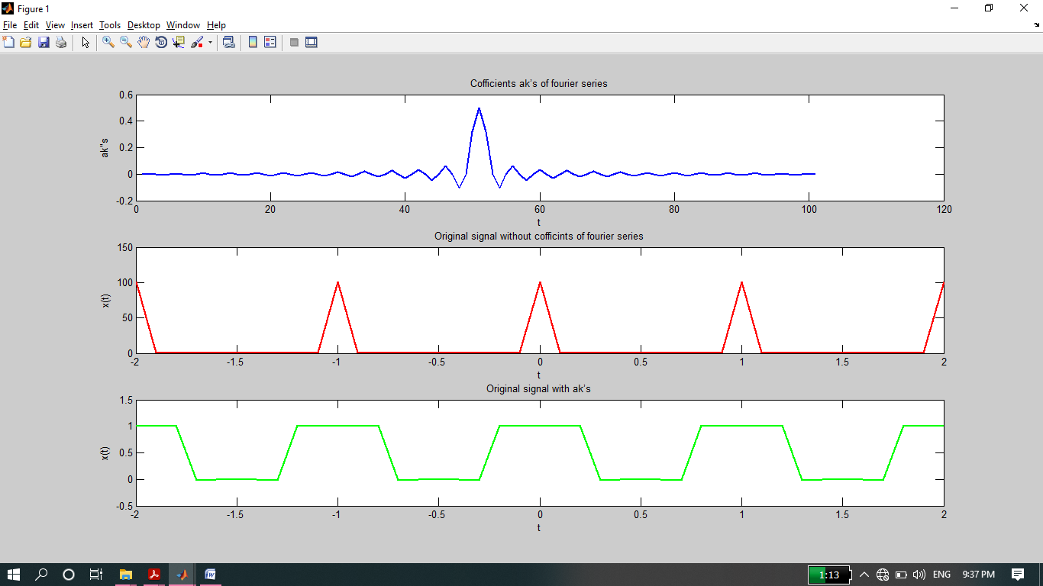

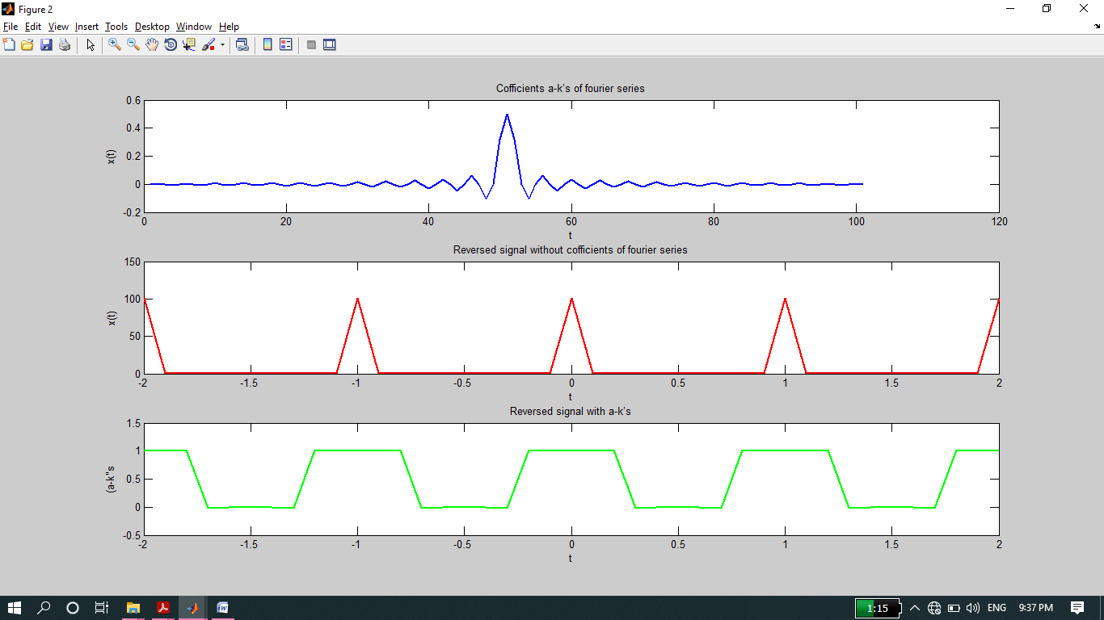

**-----------------------TASK 02--------------------------**

* Given the periodic square wave x(t) with T = 1 & T1 = 0.25, rewrite the above code for time scaling when value of alpha is 2 i.e. x(αt) = x(2t).

**Source code:**

clc

clear all

close all

% Generation of periodic square wave t = ?1.5:0.005:1.5;

t = -1.5:0.005:1.5;

xcos = cos(2*pi*t);

xt = xcos>0;

% FS coefficients of periodic square wave k = ?50:50;

k = -50:50;

T = 1;

T1 = 0.25;

ak = sin(k*2*pi*(T1/T))./(k*pi);

ak(51) = 2*T1/T; % Manual correction for a0 ?> ak(51)

% Time scaling parameters

alp1 = 2;

% w's for the time scaled signals w0 = 2*pi/T;

w0 = 2*pi/T;

w1 = alp1*w0;

% Reconstruction from ak's with 101 terms (M=50)

xat1 = zeros(1,length(t));

for k = -50:50

xat1 = xat1 +ak(k+51)*exp(j*k*w1*t);

end

figure(1);

subplot(2,1,1);

plot(t,xt,'lineWidth',2);

ylabel('x(t)');

title('Periodic Square Wave (T=1, T1=0.25)');

axis([-1.5 1.5 -0.2 1.2]);

grid;

subplot(2,1,2);

plot(t,real(xat1),'lineWidth',2);

ylabel('x(t)');

title('Reconstruction from ak''s (alp1=5, w1=0.5*w0)');

axis([-1.5 1.5 -0.2 1.2]);

grid;

**Output:**

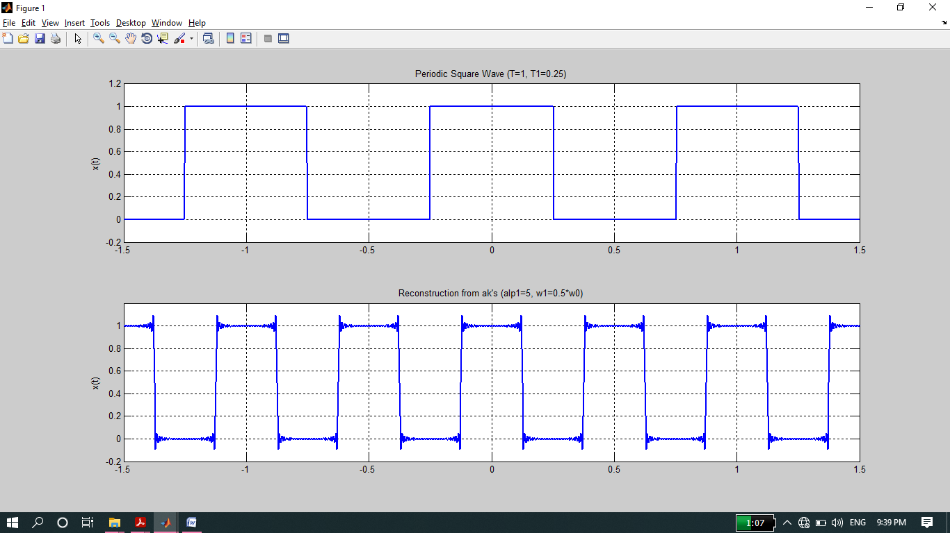

**THE END**